**COVID TRAVEL COVER**

:-by Barnini Goswami,Shreya Majumdar,Kajal Gupta

**(1) INTRODUCTION**

(1.1)*OVERVIEW*

The outbreak of coronavirus (COVID-19) has created a global health crisis that has had a deep impact on our daily lives. Lockdown was implemented to stop the spread of corona virus which has affected economy of the country. Country has to be unlocked; hence Public Transportation will have to be resumed but in such a way that no more covid-19 cases could be born. To solve this problem, we have been implementing a solution, by building an intelligent app to schedule the timings of various transports, avoiding the over occupancy of buses, railway stations etc. Our application will check the user's authenticity and accountability by asking for their details to enter while they login to our app. Purpose of travel will be kept track of for future references. This app will compare the shortest routes and will align the routes in ascending order from each source to destination, after the checking of the route availability, there will be limited number of seats(less than usual)" to provide ample amount of space inside the bus for people to maintain the social distance criteria, for all the available routes ,the seats will be booked according to the availability .So, basically this app will avoid congestion, which will actually help in maintain social distancing.

(1.2) *PURPOSE*

With surveys of what is happening around us, it is beyond any argument to state that people are not safe enough to move freely. This application describes a unique approach to solve the issue of maintaining social distance while travelling due to the COVID 19 outbreak and also to make public transportation function like it used to function early. The COVID 19 pandemic is a worldwide pandemic because of which it became risky to allow the public transportation without proper mechanism to maintain social distancing. So, to resolve this problem we came up with an idea of making an intelligent application to schedule the timings of transportation, avoiding over occupancy of public transport, providing them proper guidelines and also has a mask detection system.

The purpose of the proposed work are as follows:

1. It will help in preventing people from getting vulnerable to COVID-19.

2. It will provide the shortest route for the traveler’s desired destination thus saving time.

3. This app will be used to make public transportation possible while maintaining social distancing.

4. It will help in avoiding over occupancy of public transport.

5. Its user friendly so many people can easily use it.

6. It helps to detect on mass scale whether people are wearing mask or not.

7.It will also help in avoiding congestion on roads.

8. It will keep a track of travel of healthcare officials for analysis by maintaining a priority.

9.Payments will be online so no requirement for handling physical currency is present.

**(2)** **LITERATURE SURVEY**

(2.1) *EXISTING PROBLEM*

The upsurge of coronavirus pandemic, 2019 (COVID19) has created a global health crisis that has had a deep impact on the way we perceive our world and our everyday lives. COVID-19 is highly contagious and mortality also very high, this makes the disease all the more dangerous. One of the major preventions is to maintain social distancing, which would smash the chain of the expansion of the disease. A nationwide lockdown has been implemented for the same but we can't keep lockdown in a country for a very long time otherwise the country's economy will drastically decline. Post lockdown many things will change around us. And after the daily routine resumes, the public transportation system will play a crucial role, as it is most commonly used by people and to prevent the further spread of covid-19 cases, social distancing needs to be maintained at all the public places. So there has to be a proper management for public transportation which can allow its use, without further producing more covid-19 cases. Many such works have been done previously where people can book tickets according to their preferred transportation but those apps don’t satisfy the social distancing. Existing work in the field motivated our design idea to tackle the needs of a safer traveling environment for the public. A handful of solutions have been suggested pertaining to the issue in discussion.

(2.2) *PROPOSED SOLUTION*

The proposed work is based on specific principles and methods, which are described in this section.

The main idea is to design an App which will smartly manage the social distancing and decide the route of the transport based on crowding and shortest route.

1) The App will ask to sign up, that means registration will take place for all passengers and after signing up, an authentication page will be launched, which will ask for ID proof of the customer, so that our app could be used in the desired way.

2)Then the customer has to enter his address details in Address Page and then destination details in Destination Page.

3) Ticket booking page would be launched to book the tickets and it would show the available timings and seats observing the social distancing method.

4)The app would contain a page of Guidelines by which people will get aware of the preventive measures to be taken during this pandemic.

5) This app also has a mask detection system by which it will detect whether an individual has worn a mask or not, this will help in ensuring the safety.

*Working platforms: -*

•Frontend (UI/UX)

We will design our frontend using HTML, CSS, JAVASCRIPT in BOOTSTRAP.

•Backend

We will use Java ,Python and MySQL for backend coding. (Atom / Visual studio code).

**(3) THEORETICAL SURVEY**

(3.1) *BLOCK DIAGRAM*

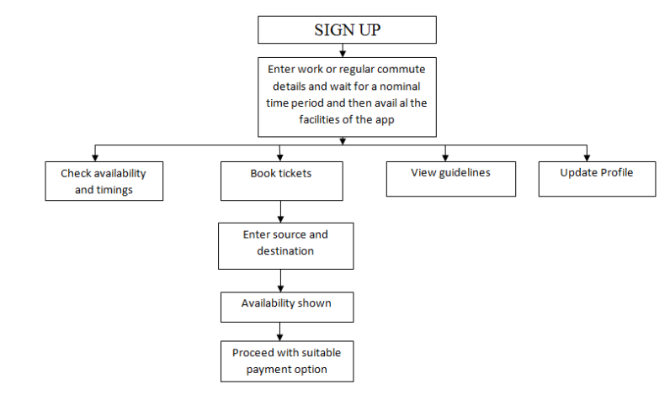i) **Registration and login: - This** would be the first step for a new user. This step would enable the user to create an id and for maintaining the authenticity every user would be required to upload the credentials of any address proof and workplace or institutional details (employee id /student id card, etc.)

ii) **Ticket booking: -** Whenever a user needs to travel, he/she will have to book a ticket online through our app at least 5 hours before they intend to start their journey. So, there will be a booking page where the users can mention the purpose, places (source and destination) and timings of their travel and will receive the tickets on the basis of availability.

iii) **Guidelines page**: - There will be a page to which any user can refer to, any time for viewing the safety guidelines to be taken to ensure they are having least risk of infection.

iv) **Facilities nearby: -** This page will be showing all the hospitals, medical shops and other healthcare and emergency facilities nearby even when the users are in transit.

v) **Alert: -** There will be an alert on the user’s screen if they are not following the social distancing criteria (using Bluetooth proximity), so that they can be aware and can safeguard themselves.

(3.2) *SOFTWARE DESIGNING*

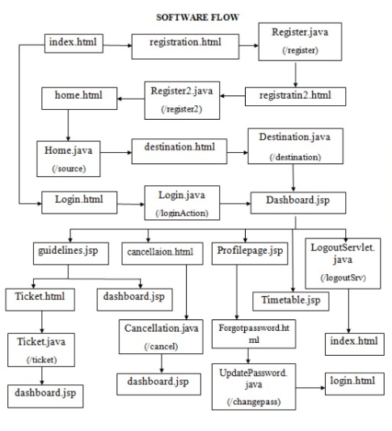

In this section the flow of the software has been defined:-

**Index.html** is the first page of our website (WELCOME PAGE). It will direct a user either to registration.html (REGISTRATION PAGE) or login.html (LOGIN PAGE).

**Registration.html** - In this page a user will fill their required details and the details will get stored in the backend database *register.java(/register)*. After this it will direct the user to the next step of the registration I.e.

**Registration2.html** -In this the user will fill the other required details remained and the details will get stored in the backend database *register2.java(/register2).*

If the user has already been registered then the user can directly go to the **login.html**(LOGIN PAGE) where his/her credentials are already there in the database *login.java(/loginAction)* .

Then the next page after registration page it will be **home.html** where a user can store his/her HOME ADDRESS so that it will get stored in the database *Home.java(/source)*, which will help user to choose their home address every time by just choosing the option home they need not to enter their home address details every time.

The **destination.html** page will ask all the usual destination details where a user want to reach and the details will get stored in *destination.java(/destination).*

Then comes the **Dashboard page(dashboard.jsp)** where the user’s recent journey will be displayed. Dashboard directs to the other pages: -

**Guidelines.jsp** - here the user can find few most important guidelines for the prevention from COVID-19 .

**Cancellation.html** from this page the user can cancel his/her booked ticket and it will then update in the database *cancellation.java(/cancel)* and then redirects to the dashboard.jsp.

**Profilepage.jsp** here people can see their information they have entered while the registration process.

**Timetable.jsp** here the user will find the timetable which will make easy for the user to see timings and book tickets according to their convenience.

*LogoutServlet.java(/logoutSev)* here the user can log out their account then will get directed to the index.html page .

From the guidelines.jsp the user can get back to the dashboard.jsp page or to the **Ticket.html** where the user will book their tickets and the data will get stored into the database *Ticket.java(/ticket)* and then directs again to dashboard.jsp.

**Profilepage.jsp** (PROFILE PAGE )contains a forgot password option which redirects to the **Forgotpassword.html**(FORGOT PASSWORD PAGE) there the user will have the provision to update his/her password and the password will get updated in the database *Updatepassword.java(/changepass)* and then this page will redirect to the login.html (LOGIN PAGE).

**(4) EXPERIMENTAL INVESTIGATION**

This section includes methods that formulated the problem, addressed a central or related problem, used a similar methodology as our work to a similar problem, and also how our work is inspired by their work. By clearly describing previous work, we can better describe the current limitations and the need for a new methodology. It also gives an opportunity to demonstrate our area of work and will help others to relate our current work to other scientific areas. We collected, analyzed and coded the author assigned keywords of other research papers to start a discussion on the topic “Intelligent post lockdown transportation management system". Presently, how to maintain social distancing while travelling is a boiling area of research. Managing traffic, safer routes and also telling the public about the shortest route to reach out their destination have been used in designing many applications in the past. Some of those existing approaches from the past are discussed in this section.

1. **Transit** app was designed for aggregating and mapping real-time public transit data, crowdsourcing user data to determine the actual location of buses and trains. This app was first released for iPhone users then it was launched for the android users as well. It offers upcoming departure times for all nearby transit lines and alerts for various types of transportation where available, including both bus and train. If it is found that public transit is not cooperating, people can easily request an Uber or grab the closest bicycle. Whether you ride the train, subway/underground /tube, bus, light rail, ferry or metro, use bikes, ride-sharing like Uber, getting the best urban mobility information is critical.

2. **Moovit** guides you from point A to B in the easiest and most efficient way. Get train and bus times, maps, and live arrival times with ease so you can plan your trip with confidence. Find critical alerts and service disruptions for your favorite lines. Get step-by-step directions of optimal route bus, train, metro, bike or a combination of them.

3. **GoTo** is the First ever Real-time Bus Booking Platform for Intercity Travels. It is focused on saving your precious time which is generally wasted waiting for buses at the Boarding point, with No Clue of bus arrival. Though on booking operators claim that you can track the bus, in most of the cases you are unable to get its actual expected time of arrival.

All the above-mentioned applications help people to book tickets, reach their destination in time, provide them with a scheduled time table and notify them of numerous modes of transportation. There are several such applications like Chalo, UTS, NextBus etc. So, after exploring all the previous works we have come up with an application which in addition to existing features provides new and innovative ways to implement social distancing in public transport. After exploring several design options, we eventually decided to develop a website which will have features from several of our brainstormed and existing ideas named COVID TRAVEL COVER. By integrating the features of distinct applications together in one platform, COVID TRAVEL COVER offers a more holistic and effective solution than the existing applications by providing them with a variety of tailor-made features as per user’s requirements. Another highlight is that the currently available applications fail to provide a solution to the COVID-19.

**(5) FLOWCHART**

**The flowchart of the TICKET ALLOCATION is given below:-**

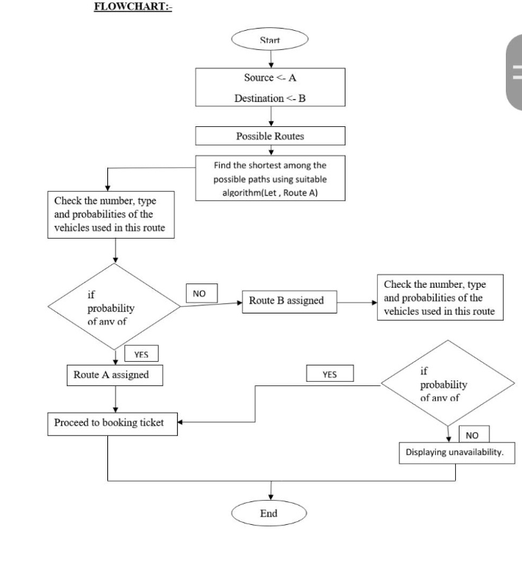

(a) **Shortest path algorithm**:- If there will be more than one person requesting for the same path, they will be allocated ticket through the shortest path on first come first served basis.

(b) **Traffic management**:- The app will try to optimize the journey of people in a way that most people are able to go through the best possible route and also avoiding traffic congestion at the same time in all routes as long as possible.

**(6) RESULT**

The outcome of whatever done till date has been mentioned below.

**A . FRONTEND**

1. COVER PAGE

This is the index page of our website .

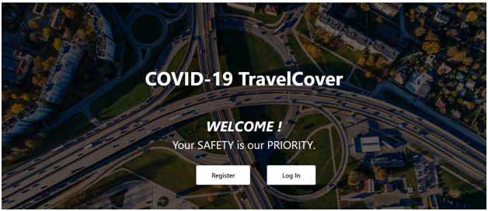

2. LOGIN PAGE

Those who already have an account here on our website can LOG IN directly by :-

1.Entering the username.

2.Entering the password.

Click on to the LOGIN button.

If a person has forgotten his/her password then they can click on to the Forgot your password option .

OR

If a person don’t have an account can click on to the Don’t have an account option.

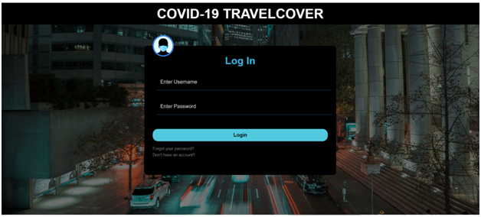

3. REGISTRATION PAGE

If a person doesn’t have an account can directly to go to the registration page .

In this SIGN UP page the user needs to enter :-

1.First Name.

2.Last Name.

3.Email Address.

4.Mobile Number.

Choose their gender.

Click on Next button to complete his/her Registration form.

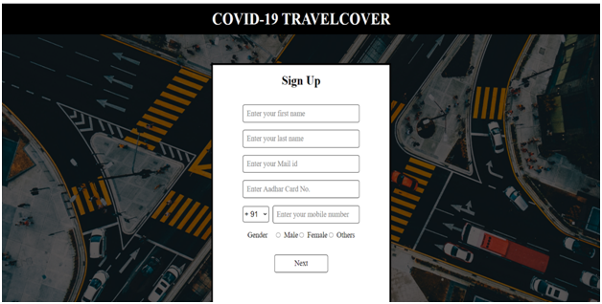

In the next page you need to enter :-

1.Username

2.Confirm the email.

3.Enter the password of your choice.

4.Re-enter the password.

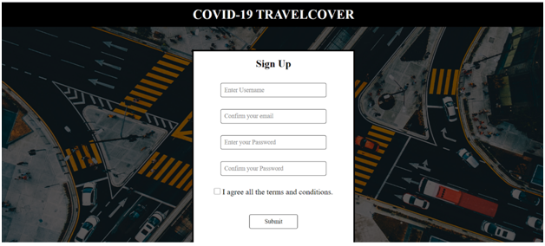

4. HOME ADDRESS

In this home address page the user can save the address of their so they can easily choose home rather than entering the address of their home everytime.

In this box the user needs to fill up their :-

1.Username

2.Address of their home

3.Choose the State.

4.Enter their Pin Code.

Click on the SUBMIT button.

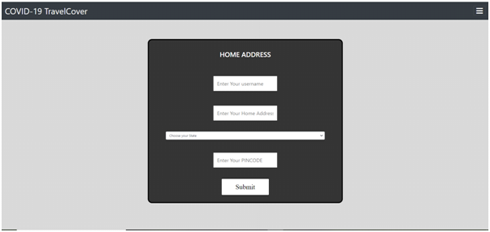

5. DASHBOARD

An informative page about the user’s upcoming journey and this page also has a blog.

This page also has a Cancel Your Ticket button (for the user to cancel his/her ticket).

And from now, on every page there will be a hamburger menu to toggle between pages.

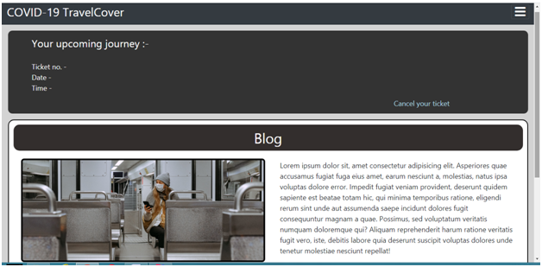

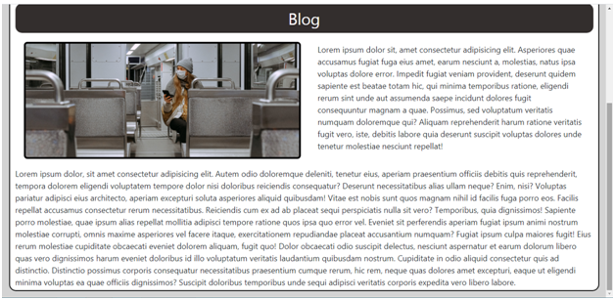

6. GUIDELINES

This page provides the users a set of general instructions which are essential to be followed in public places and transport.

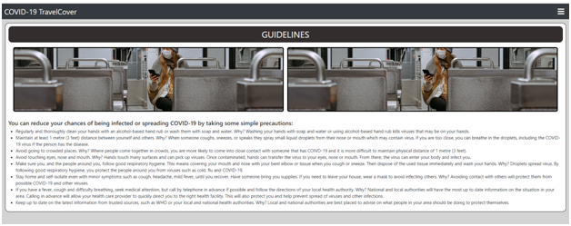

7..This timetable shown in our app is dynamic.

The changes the in the time of the buses will get updated as soon as the database gets updated.

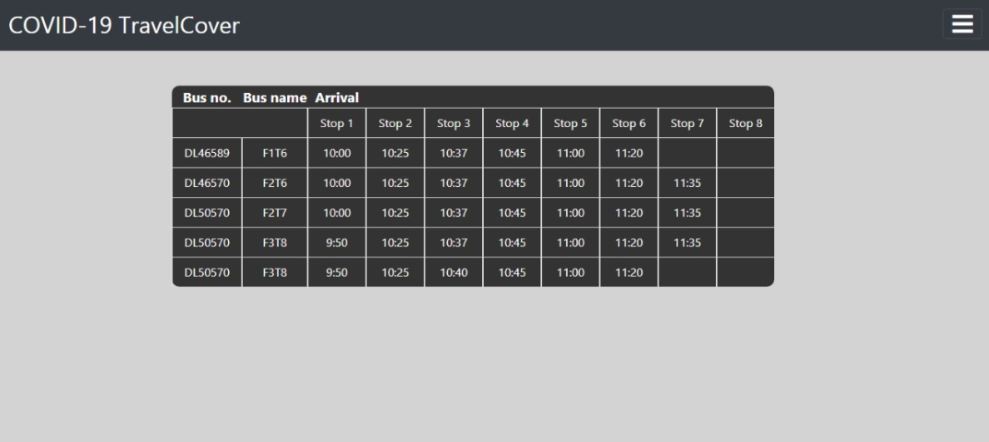

8. TICKET-BOOKING

This box appears for the booking of the ticket ,here the user need to:-

(a) Enter the source pin code (from where he/she will start his/her journey).

(b) Enter the destination pin code (where he/she will end his/her journey).

(c)Enter the purpose for which the user wants to move from one place to another(this purpose entries will help to define the priority of one’s work ).

(d) Enter the date(day, month and year) and time .

After the completion of the box needs to click on the Proceed button.

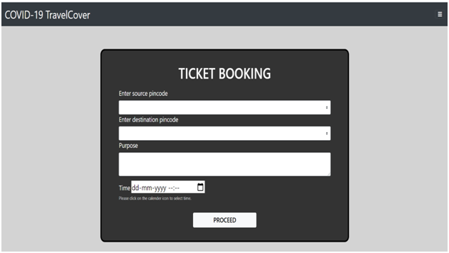

9. CANCELLATION PAGE

(1) After clicking on to the “Cancel your ticket” button on dashboard page, this cancellation page will appear , the user needs to enter his/her ticket number then will click on the “Cancel Request” button.

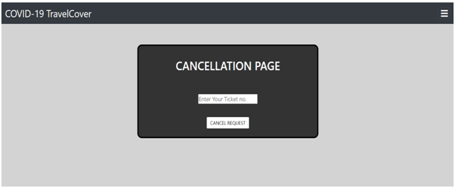

(2) As soon as the user clicks on the “Cancel Request” button , a prompt pops up where the user needs to enter his/her password then needs to click on OK button.

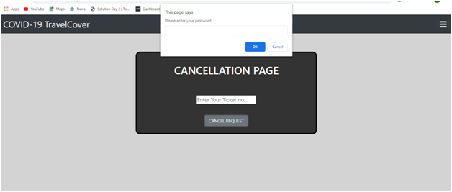

(3) After clicking on to the previous prompt’s OKbutton ,another prompt will pop up which will ask the user for his/her cancellation’s confirmation.

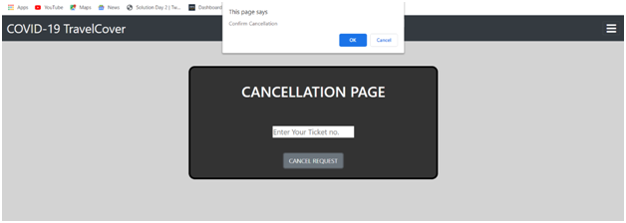(4) As soon as the user confirms his/her cancellation , another prompt will appear will the confirmation of the user’s ticket’s cancellation.

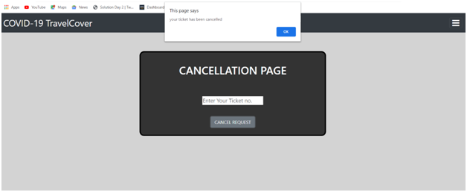

10.FORGOT PASSWORD

Here in this page the user can change their password ,if they forgot it by entering specified details:-

1.New Password

2.Confirm New Password

Click on the SUBMIT button.

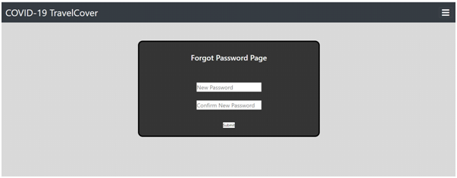

*MASK DETECTION SYSTEM*

This system is made to detect the user is wearing a mask or not .

The user need to upload his/her picture and will get detected by our app.

**UNMASKED**

The user is not wearing a mask.

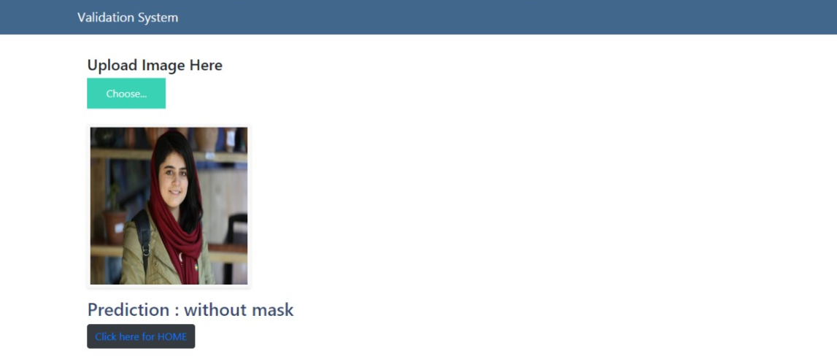

**MASKED**

The user is wearing a mask.

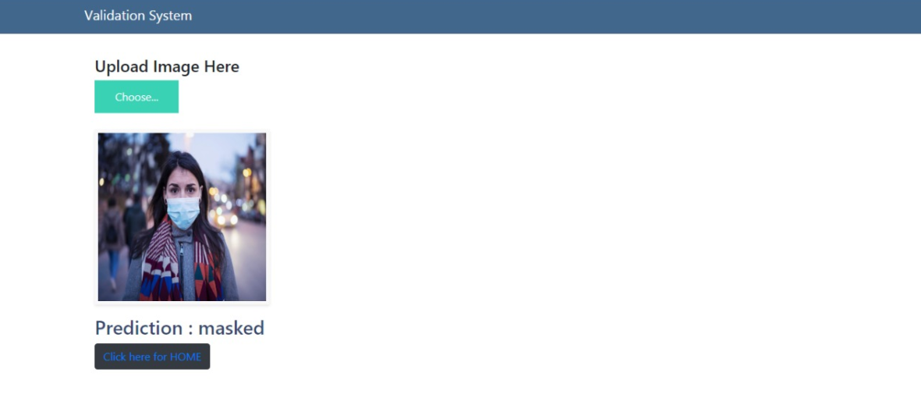**B. BACKEND**

We would like to explain the working of our website with the help of an example.

1. Let us suppose there were two entries already present in our "IBMregistration table"(maintains data of users).

The entries made in first page of registration, named “registration.html” will be stored as shown below.

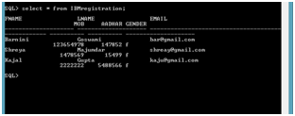

2. After filling the details of the first page the user will be redirected to the next page, named “registration2.html”. Here user will be required to enter the user name and password of their choice and the data will be stored as shown below.One important thing to notice in this case is that the table “user_credentials” has two extra columns other than the details entered by the user. Therefore, initially the default values for these two columns will be set to zero and will be updated later.

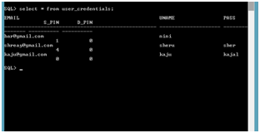

3. On moving forward the user would be required to fill the usual source address details according to which the “s_pin” column of ”user_credentials” table will be updated which would represent the source PINCODE of the user. The change in column’s value can be noticed in the picture below.

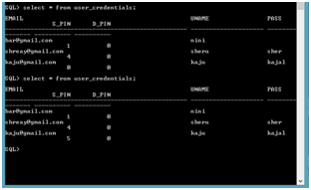

After following all the above steps the user will become a registered user of our website and can enjoy all the available facilities.

4. Now, moving on to the routing details. There is a table named “route_details” which holds the route names and the corresponding pin codes in order of their traversal.

When a user will enter the source and destination pin code while booking the ticket then the program logic will search for routes containing both the pin codes and will find the shortest of all the routes.

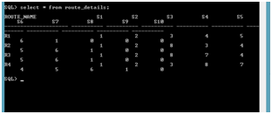

5. Initially, the table “route_availability”, which contains the number of available seats in a particular route contains full availability(assuming 5 seats per bus for testing purposes).

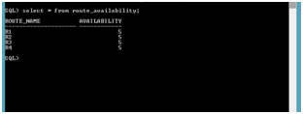

6. If some user books ticket from pin code “1” to pin code “5” , the logic finds that the shortest path is “R1” and thus updates the seats in a way to represent one ticket have been booked so the availability of route “R1” becomes 4 now.

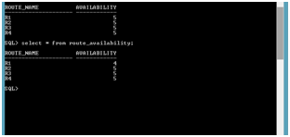

7. The backend of the bus timetable ,here this time table is built dynamically so that whenever there is some changes in the timings it can directly be changed in the database which will help the user to see the proper timetable containing information of bus number ,it's arrival and departure timings.

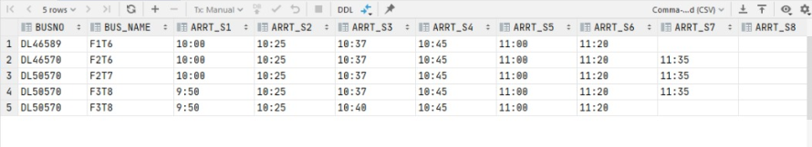**(7) ADVANTAGES AND DISADVANTAGES**

*ADVANTAGES*

1.Keeps track of priority of purpose of travelling for analysis and future references.

2.Safety guidelines for user to read first before booking the tickets

3.Restricting the numbers of people that can board a bus to much less than actual capacity thus allowing the users to follow social distancing inside the bus also.

4. No physical money transaction present this reduces the spread of infection through currency.

5.Keeps a check on traffic congestion thus avoid crowd on roads.

6.Easy booking and cancellation from home itself.

7. Updating information is easier.

*DISADVANTAGES*

1. The people those who are not having system or internet connection won't be able to use this application.

2. The mask detection feature of our app might not work properly incase an unsuitable picture is uploaded.

3. Although we have provided guidelines to the user but following them is their own responsibility.

**(8)** **APPLICATIONS**

Public transportation should function seamlessly for daily purposes during and after the coronavirus pandemic but now while maintaining social distance, our app provides a feasible method to do so. Travelers can book tickets according to the seating plan which would be made keeping social distance rule in mind.

And the shortest route algorithm used to make allocate seats through tickets will control the congestion on roads also refuse the overall time an individual is exposed to the virus. Basic guidelines are also there for users to read thus constantly reminding them what and how to follow.

**(9) CONCLUSION**

Now we desperately need a dependable solution to tackle the growth of infections of COVID-19 and that would facilitate proper public transportation management post lockdown. Once the lockdown ends, there needs to be elaborate planning to manage all the people using public transport as offices, factories etc. will start functioning. So, to ensure everyone’s wellbeing and safety we are introducing an intelligent post lockdown management system for public transport which will help in avoiding over occupancy of public transport and will help people to maintain social distancing which will lower their risk of getting infected by COVID-19.In our application, we will keep a track of purpose of each passengers travel and maintain a record for healthcare officials using our application for analysis and future prospects. Through our ticket booking system we will try to reduce the transit time for users as much as possible thus saving time and comparatively reducing the risk of the individual getting infected. All the money transactions would be done through e-currency thus reducing the chances of infection being spread through physical currency.

**(10) FUTURE SCOPE**

In this pandemic this app is extremely necessary keeping in view the current situation of rising cases in the country.

This app would allow seamless functioning of public transportation even in these worst conditions to help stabilize the economy again.

Although we have tried to implement all the features that we had planned but scope of improvement is always there.

In mask detection system instead of asking the user to upload a photo we can implement this feature over webcam or front camera in case of mobiles., so that there will be no possibility of uploading an unsuitable picture.

We can implement a penalty system which would include imposing penalties on users who would violate the guidelines mentioned in our application.

**(11) BIBLIOGRAPHY**

[1] Q. T. Nguyen, N. Ba, and T. Phan, “Scheduling Problem for Bus Rapid Transit Routes,” in Advances in Intelligent Systems and Computing, 2015, vol. 358, pp. 1–415.

[2] “Effects of COVID-19 on Transportation Demand, 2020.” [Online]. Available: <https://www.teriin.org/article/effects-covid19-transportation-demand>. [Accessed: 23-May-2020].

[3] T. M. L. Yu B., Lam W. H., “Bus arrival time prediction at bus stop with multiple routes,” Transp. Res. Part C, vol. 19, no. 6, pp. 1157–1170, 2011.

[4] “No Title.” [Online]. Available: <https://play.google.com/store/apps/details?id=com.thetransitapp.d> roid&hl=en. [Accessed: 23-May-2020].

[5] “Moovit: MaaS Solutions & the #1 Urban Mobility App.” [Online]. Available: <https://moovit.com/>. [Accessed: 24-May2020].

[6] R. Matheus, M. Janssen, and D. Maheshwari, “Data science empowering the public: Data-driven dashboards for transparent and accountable decision-making in smart cities,” Gov. Inf. Q., no. February, pp. 0–1, 2018.

[7] “Home - GoTo Bus.” [Online]. Available: <https://www.gotobus.in/>. [Accessed: 24-May-2020]. [8] O. Cats and G. Loutos, “Real-Time Bus Arrival Information System: An Empirical Evaluation,” J. Intell. Transp. Syst. Technol. Planning, Oper., vol. 20, no. 2, pp. 138–151, 2016.

[9] Shalaby A. and Farhan A, “Prediction model of bus arrival and departure times using AVL and APC data,” Public Transp., vol. 7, no. 1, pp. 41–61, 2004.

[10] and T. T. Cats O., Koutsopoulos H.N., Burghout W., “Effect of real-time transit information on dynamic passenger path choice,” Transp. Res. Rec., vol. 2217, pp. 46–54, 2011.

[11] Y. Tan, “A New Shortest Path Algorithm Generalized on Dynamic Graph for Commercial Intelligent Navigation for Transportation Management.,” 2019.

[12] D. Ferone, P. Festa, A. Napoletano, and T. Pastore, “Shortest paths on dynamic graphs: A survey,” Pesqui. Operacional, vol. 37, no. 3, pp. 487–508, 2017.

[13] Y. Tan, “snatchagiant/Shortest-paths-algorithm-over-dynamicgraph-for-transportation-management.” .

[14] Jinhao Lu and Chi Dong, “Research of shortest path algorithm based on the data structure,” in 2012 IEEE International Conference on Computer Science and Automation Engineering, Beijing, 2012, pp. 108–110.

[15] W. Zhu and R. Li, “Research on dynamic timetables of bus scheduling based on dynamic programming,” Proc. 33rd Chinese Control Conf. CCC 2014, pp. 8930–8934, 2014.

[16] G. Aceto, D. Ciuonzo, A. Montieri, V. Persico and A. Pescapé, “MIRAGE: Mobile-app Traffic Capture and Ground-truth Creation,” in 2019 4th International Conference on Computing, Communications and Security (ICCCS), Rome, Italy, 2019, pp. 1– 8.

[17] G. A. N. S. and S. A. P. S. Al Perumal, M. Tabassum, N. M. Norwawi, “Development of an Efficient Timetable System using AngularJS and Bootstrap 3,” in 2018 8th IEEE International Conference on Control System, Computing and Engineering (ICCSCE), Penang, Malaysia, 2018, pp. 70–75.

[18] T. Xu, F. Shi, and W. Liu, “Research on open-pit mine vehicle scheduling problem with approximate dynamic programming,” Proc. - 2019 IEEE Int. Conf. Ind. Cyber Phys. Syst. ICPS 2019, no. 71790614, pp. 571–577, 2019.

[19] L. E. and N. N. N. Jasika, N. Alispahic, A. Elma, K. Ilvana, “Dijkstra’s shortest path algorithm serial and parallel execution performance analysis,” in 2012 Proceedings of the 35th International Convention MIPRO, Opatija, 2012, p. N. Jasika, N. Alispahic, A. Elma, K. Ilvana, L. El.

[20] P. Bogdan, “Dijkstra algorithm in parallel- Case study,” in Proceedings of the 2015 16th International Carpathian Control Conference (ICCC), Szilvasvarad, 2015, pp. 50–53.

**(12) APPENDIX**

***SOURCE CODE***

JAVA(BACKEND)

The java file is **Ticket.java.**

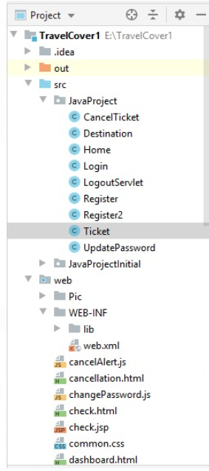

This app helps to find the shortest route from source to destination ,route availability and ticket booking.So,the main logic of this feature is shown below:-

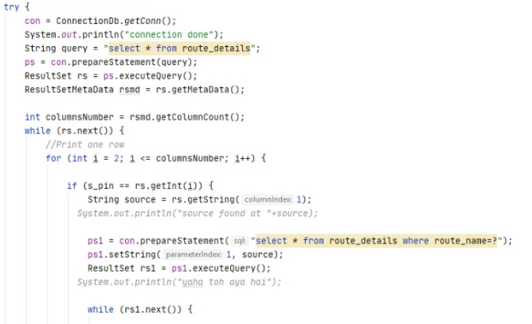

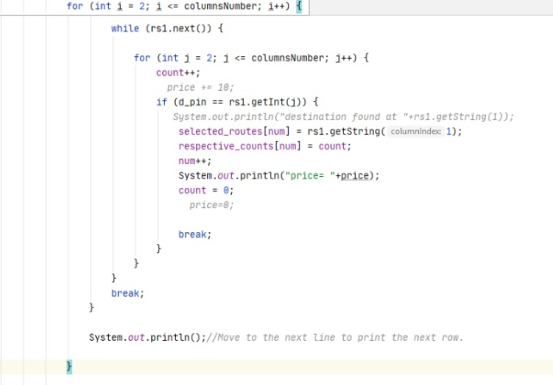

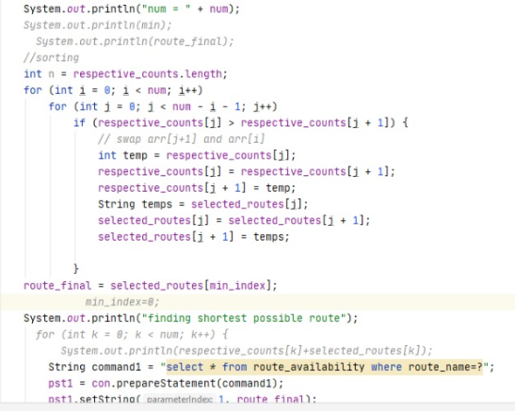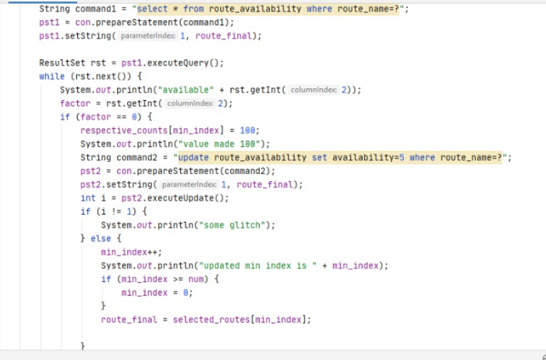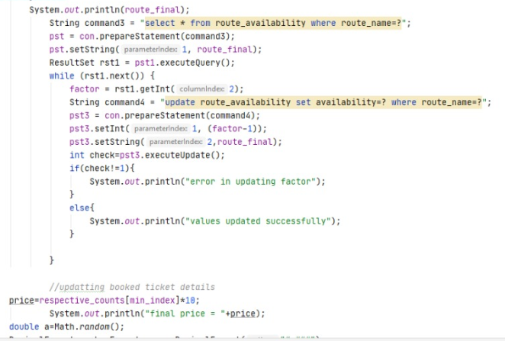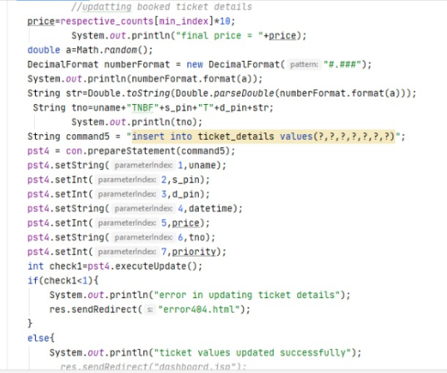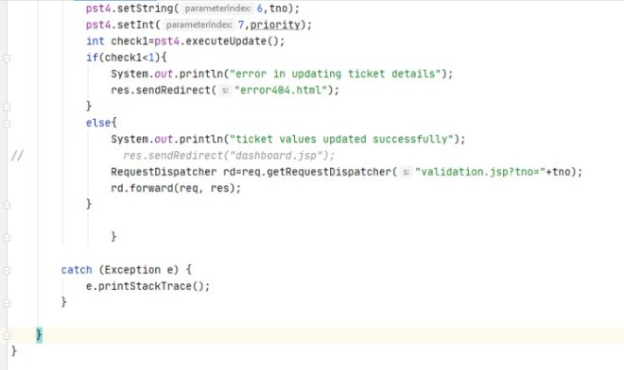

The second most important feature of our app is **MASK DETECTION SYSTEM.**

(from IBM HACK CHALLENGE bootcamp)

The file name is **app.py.**

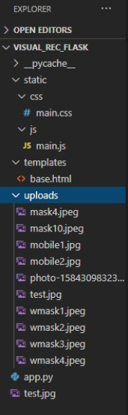

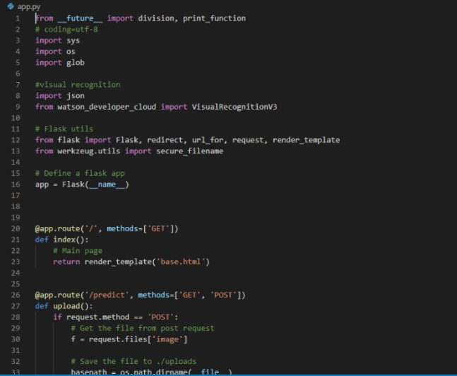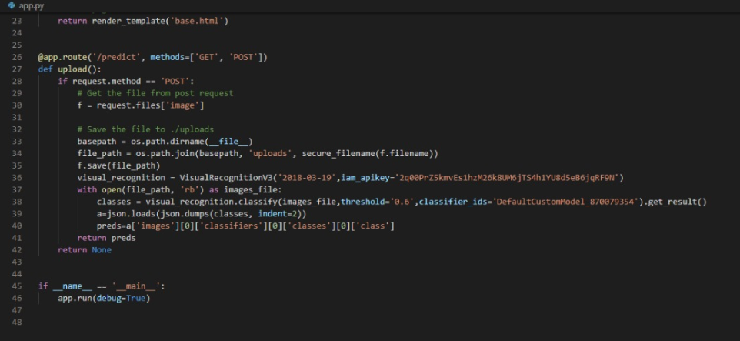

The FRONTEND file of this MASK DETECTION SYSTEM is **base.html .**

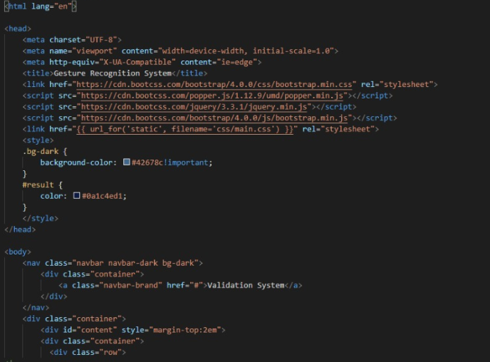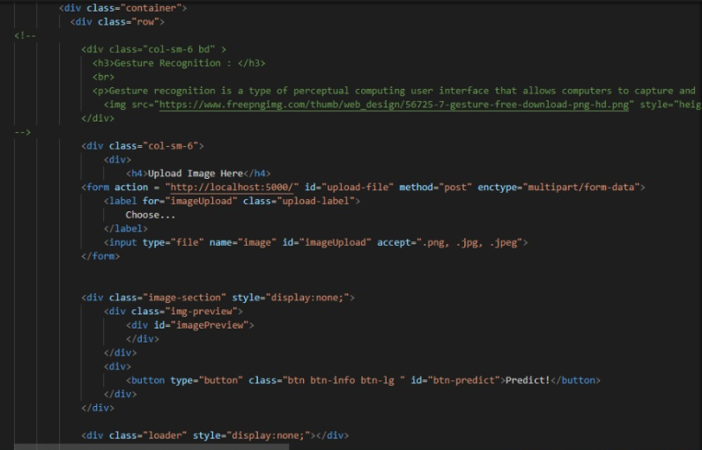

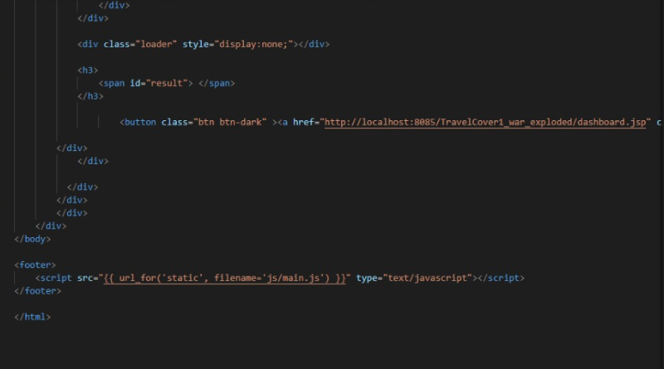

**-------------------------------------END OF REPORT----------------------------------------**